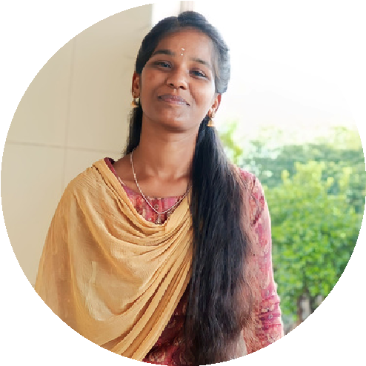

91-8838806288 yogaprakasam07@gmail.com

Sekkodi ,

Dharmapuri(dt), pincode-636809.

# EDUCATION

**B.Tech-AI&DS(Anna University)**

**2021-2025**

**CGPA-8.04**

**Avvaiyar Government Girls Higher Secondary School**.

**(12th)-2019-2020 Score-510**

**(10th)-2018 Score-405**

# EXPERTISE

Excel

Tableau

Power BI SQL

Jupyter NoteBook

Web Scrapping(Pandas)

Web Design(HTML,CSS,BootStrap)

# YOGA PRAKASAM

D a t a A n a l y s t

h t t p s : / / w w w . l i n k e d i n . c o m / i n / y o g a p r a k a s a m

## ABOUT ME

-I had good communication skills and LEADERSHIP skills -I am a good Self Motivator.

-I am Active Learner and I had lot of interest in Data Analytics & Web Development.

**-**I will Easily adopt new environment.

## INTERNSHIP

**Salem-**IMAGECON(Machine

Learning) using CNN algorithm

**Erode-**IDM TechPark(Data Analytics) using Excel,PowerBI,Tableau,SQL

## WORKSHOP

**Salem-**Salem Polytechnique College(Machine learning).

## PAPER PRESENTATION

**Salem-**AVS college(Artificial

Intelligence and Advance Techniques)

**Namakkal-**Paavai Engineering

College(Machine Learning and Algorithms)

**Salem-**Salem Engineering College(Cyber Security).

### EXTRA CURICULAR ACTIVITY

Dance

Singing

Sports

Drawing

### LANGUAGE

English

Tamil

### DECLARATION

I here by declare that the above-affirmaed in formation is all true to the best of my knowledge